The Rainbow Body and the Inner Light: Phosphenes in Tibetan Mysticism
A Phenomenological Inquiry into Vision, Light, and Consciousness in the Dzogchen Tradition
Author: Jan M. Keppel Hesselink, MD, MSc, PhD, Independent researcher, Meditation Centre Quinta Quixote, Algarve, Portugal
Abstract The rainbow body (jalü in Tibetan Buddhism) signifies one of the highest forms of spiritual realization, described as the dissolution of the physical form into light at death. This paper proposes that the visual dimension of this experience can be understood as a complex, dynamic phosphene-movie, a vivid internal luminosity emerging from neural and phenomenological processes. We further introduce the haptic dimension of meditative experience, including sensations of levitation and expansion, not as secondary effects but as co-creative forces shaping the luminous field of perception.
Drawing from Dzogchen texts, iconography, and a six-phase taxonomy of inner light, we identify striking parallels between traditional accounts and the neurophysiology of phosphenes. We interpret Tibetan thangkas as visual maps of these inner luminous processes, encoding both visionary and tactile dimensions of meditative perception. The integration of these experiences, where the practitioner becomes the ascending light-form, is proposed as a passive mode of Guru or Deity Yoga, a spontaneous embodiment of luminous awareness.
We conclude that Dzogchen may represent a historically unparalleled system for entering and navigating an ultrasubjective hyperspace (USH), a collective and experiential domain of consciousness structured by light itself. In this framework, the rainbow body is not merely symbolic but phenomenologically grounded: a vision of mind recognizing its own radiance.
Keywords:
Phosphenes; Rainbow Body; Dzogchen; Tibetan Buddhism; Inner Light; Neurophenomenology; Consciousness Studies; Mystical Experience; Ultrasubjective Hyperspace; Haptic Perception; Meditation; Guru Yoga; Deity Yoga; Thangka Iconography; Luminous Awareness; Comparative Mysticism.

1. A Personal Encounter with Inner Light and Ascension
I started meditating and yoga when I was 17. Now I am 71 and dare to share some insights for those fascinated in the potential of meditation. The genesis of this paper lies not in ancient texts, but in a direct, deeply immersive personal experience, and autoethnographical approach (Ellis, 2011). During a profound meditative state, my internal vision unfolded into what can only be described as a phosphene-movie. Vibrant, luminous colors, the full spectrum of the rainbow, swirled and coalesced, forming magnificent, elongated banners of light that seemed to undulate and ascend around my body. Within these radiant, upward-moving streams of color, a luminous, ethereal body began to emerge, not as something external, but as me, in the centre of my perception. I felt myself being in the axis, in the middle of this upstreaming surge created by all these rainbow-banners spiraling around me and carrying me upwards.
Crucially, this visual spectacle was inseparable from a powerful haptic sensation of floating upward. This wasn't just a feeling of my physical body ascending; it was the distinct, undeniable sensation that the entire visual construct, the rainbow banners and the radiant body within them, was lifting, and I was utterly integrated with it. The upward movement of the light-banners and the body was one with my own sensation of ascension. There was no dissociation; the visual and haptic experiences were unified, each informing and reinforcing the other, creating an illusion of effortless, luminous dissolution and ascent. It felt like a spontaneous, passive form of Guru Yoga or Deity Yoga, where I wasn't actively visualizing myself as a divine form, but rather, the luminous form became me, effortlessly. The entire luminous stream of light ended in total dissipation and in I would say a multidimensional, timeless and structureless space of light.
This profound, multisensory experience after the meditation prompted a burning question: Could this internal 'movie' be a manifestation of advanced phosphene generation, and if so, what were its connections to historical spiritual phenomena, particularly the rainbow body described in Tibetan Buddhist traditions? Clearly this also is a contribution to neurophenomenology (Varela,1996).

2. Introduction: Towards a Collective Ultrasubjective Hyperspace
The concept of the rainbow body, or Jalü in the Dzogchen tradition of Tibetan Buddhism, describes a highly advanced spiritual realization where the physical form transmutates into pure light at the moment of death, leaving behind no physical remains or only minor vestiges like hair and nails (Tiso, 2016). While such an event is extremely impressive, the rainbow body also has its representation in the field of consciousness of the meditator. Moreover, as illuminated by the personal experience detailed above, the subjective visual and haptic elements of such a profound experience of a rainbow body also points towards transcendence, up and into the light, dissolving all elements of our ‘ego’ in the field of consciousness. This paper seeks to explore a novel hypothesis: that the visual characteristics of the rainbow body experience, as particularly vivid in the aforementioned personal account and depicted in sacred art, may correspond to complex, internally generated visual phenomena known as phosphenes (Keppel Hesselink, 2025a). Phosphenes are often dismissed as meaningless retinal noise, yet empirical research in vision science increasingly supports the view that perceptual content arises from active neural modeling rather than passive reception (Purves & Lotto, 2003). While the influence of phosphenes by auditory stimuli is documented, it is the base of reading the Tibetan book of the death during dying, the interaction between haptic (tactile/proprioceptive) sensations and phosphene generation remains largely unexplored (Evans-Wentz, 1960). This paper will argue that the described experience, where the feeling of floating upward was intrinsically linked with the visual upfloating of rainbow banners and the embodying form, represents a seamless, co-arising, and unified multisensory event. Furthermore, we propose that Thankas, traditional Tibetan Buddhist scroll paintings, serve as ancient visual records of these intricate internal phosphene. As Evan Thompson notes, internal visual phenomena such as hypnagogic imagery and lucid dreams reveal structured, immersive inner worlds governed by cognitive and neural dynamics (Thompson, 2015). The phosphene-movie described in chapter 1, may represent a meditative analog of such endogenous imagery. Moreover, the integration of these visual and haptic experiences, where the 'viewer' spontaneously embodies the ascending light form, is presented as a passive yet profound manifestation of Guru Yoga or Deity Yoga, offering a unique perspective on the intersection of consciousness, neuroscience, and spiritual practice (Yeshe, 2001).
Moreover, the paper illustrates that the Dzogchen tradition represents perhaps the most elaborate and systematically explored method for collectively entering and mapping an "ultrasubjective hyperspace" through specific meditative practices (Keppel Hesselink, 2025b). We have defined the Ultrasubjective Hyperspace in our previous paper as: “The Ultrasubjective Hyperspace (USH) is a profound and verifiable inner dimension of pure consciousness, transcending ordinary subjective experience. It is experientially recognized as an empty yet vibrant field of infinite consciousness, a primordial and luminous presence (Urlicht or clear Bardo-like light), within which one directly realizes their true nature as boundless and interconnected awareness. This direct recognition evokes a deep sense of awe, gratitude, and an authentic understanding of universal truth, revealing what it means to be human and how to embody that truth in daily life.”
This hyperspace is primarily accessed via what we call phosphene meditations, which form the very backbone of the culture's engagement with the nature of reality. Generations of Tibetan masters and practitioners, through techniques like dark retreats and sky gazing, have meticulously explored this internal canvas of consciousness. They have charted the "fractalized compartments" and "sacred geometry of light" that emerge from the very structure of their own awareness, culminating in the experience of the primary clear light, the "structure-function unity" of consciousness, understood as spaceless, timeless, and dimensionless. It is within this rich, collective subjective realm, born from primary experiential insight, that many of the profound symbols and metaphors of Tibetan Buddhism find their empirical genesis. And as Reynolds (2005) notes, the Bonpo Dzogchen tradition understands luminous visionary experiences not as hallucinations, but as the unfolding of inner reality through the interplay of energy, mind, and space.
2.1. Justification for Studying the “Phosphene Movie” in Consciousness Studies
The study of phosphenes, self-luminous visual phenomena arising without external light input, offers a rare empirical window into the intrinsic activity of the visual system and the architecture of consciousness itself. What we call in this paper the “phosphene movie,” is a sequential unfolding of spontaneous inner imagery during meditation, sensory deprivation, or altered states. This reflects the dynamic interplay between neurophysiological processes and phenomenological content. Despite their ubiquity across cultures and contemplative traditions, phosphenes remain underexamined in contemporary cognitive science. Investigating their structure, progression, and symbolic transformation can provide critical insights into perception, imagination, and the genesis of visionary experience. As such, phosphenes constitute a natural bridge between first-person phenomenology and third-person neuroscientific inquiry, meriting their inclusion in the core canon of consciousness research.

3. The Rainbow Body Phenomenon in Tibetan Buddhism
The rainbow body (Jalü) is one of the most revered and enigmatic attainments in the Dzogchen tradition. It signifies a complete integration of the practitioner's physical and subtle bodies into a luminous, pure form, often described as a body of light, rainbow-colored, or an ineffable clear light (figure 1). Historical accounts from various lineages recount numerous instances of masters attaining the rainbow body, with consistent phenomenological details.
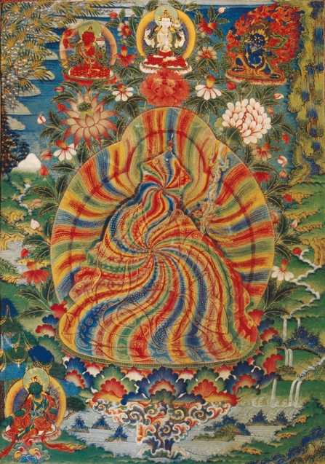
Figure . The rainbow body of Padmasambhava, Wikipedia
For example, the Testament of Padmasambhava describes the dissolution of King Trisong Deutsen from "the feet upward," a process that culminates in his disappearance (Tsogyal, 2004). Similarly, the Bon tradition speaks of the "mu cord" (dmu thag), a luminous umbilical cord or rope of light, which served as a primordial connection between the earthly and heavenly realms, enabling ancient kings to ascend directly into the sky at the end of their lives, without leaving a physical body (Geisshuesler, 2024). This profound imagery of physical dissolution into light and upward ascension is deeply embedded in the historical and mythological structure of Tibetan spirituality. It points towards a consistent, shared understanding of advanced spiritual realization involving a transformation into pure luminosity and initially a vertical movement. Even titles for historical teachers, such as "dispenser of light" ('od kyi 'byung gnas), found in traditional texts, further underscore the deep-seated cultural association of realized beings with the emanation or experience of light phenomena. This historical continuity underscores that the visual and processional characteristics of the rainbow body, particularly the dissolution into light and upward movement, are profoundly resonant with ancient Tibetan cultural and spiritual narratives, pointing to a deeply ingrained experiential archetype.

4. The Phosphene Movie Hypothesis: Unpacking the Rainbow Body's Visuals
This is the core of our argument. We propose that the visual elements of the rainbow body experience, rainbow colors, swirling lights, banners, ascending forms, are consistent with complex, dynamic phosphene patterns. Under specific altered states of consciousness, perhaps induced by contemplative practices, these phosphenes can become highly organized and coherent, forming a "movie like" sequence.
Such phenomenological descriptions of evolving light forms are not confined to modern subjective accounts but are deeply embedded in ancient Tibetan Buddhist narratives. For instance, in a cosmogonic myth central to Dzogchen, as recounted in works discussing 'sky gazing' meditation, the universe originates from a "youthful body in a vase" (gzhon nu bum pa’i sku) which "breaks open to shine forth rainbow-colored lights." The narrative further describes the primordial Buddha, Samantabhadra, attaining liberation by "recognizing himself within the luminous display of light rays emanating from the vase of light."
This striking imagery offers a profound textual parallel to the phosphene movie hypothesis. The "rainbow-colored lights" directly correspond to the dynamic, internally generated visual phenomena of phosphenes. The "body in a vase" that "breaks open" and emanates light mirrors the dissolution of form into pure luminosity. Most significantly, Samantabhadra's self-recognition within this "luminous display" resonates powerfully with the subjective experience of the self becoming one with the ascending light body, a core element of the passive Guru Yoga discussed earlier. This mythological narrative, therefore, can be viewed as an ancient, highly symbolic depiction of a multi sensory internal experience akin to a complex phosphene phenomenon, indicating a deep traditional awareness of such inner light displays.
Further reinforcing the sophisticated nature of these internal light experiences, historical accounts describe highly structured and narrative-driven visions. For example, ‘the great treasure revealer’ Guru Chöwang (1212–1270), prior to revealing his first major treasure, is said to have "traveled to the thirteenth level of the sky where he met Vajrasattva inside a tent of light and received a vase of elixir" (Chöwang, 1979, vol. 1, p. 12a).This account vividly illustrates a complex, immersive "phosphene movie" that includes not just abstract lights but a specific environment ("tent of light"), a divine figure (Vajrasattva), and an interaction, all occurring within a context of profound upward movement and spiritual significance. Such detailed visions provide strong historical validation for the possibility of highly organized, narrative like phosphene experiences that transcend simple flashes or patterns.
The mechanism behind the discovery of "mind treasures" (dgongs gter) provides even more direct textual support for the concept of "phosphene meditation." Unlike "earth treasures" which are physical artifacts, like old scrolls found in caves, mind treasures involve a mental process wherein a ‘text’, "buried in the discoverer’s mind," is revealed. Critically, these texts are described as being "encoded in the 'genuine awareness of radiant light'" and recovered through a process of "pure vision" (dag snang). This is quite comparable to the concept of reading the Akasha chronicles from western esoterists. The text explicitly states that "the mechanism of perceiving the treasure text closely reproduces the rhythm of the appearance of the visionary manifestations during Tögal, where "the manifestations move gradually from an initial dawning in the form of unclear appearances that are changing and shaking randomly to increased clarity and stability" (Gyatso, 1998, 159–73). This detailed phenomenological description of light manifestations evolving from chaotic uncertainty to clear, stable forms is remarkably consistent with the known characteristics and progression of complex phosphenes. It powerfully suggests that these "mind treasures" are accessed and perceived through the organization and resolution of internally generated luminous visual experiences, ultimately culminating in the "spontaneous translation of visionary texts." This demonstrates a sophisticated traditional understanding of the experiencing of inner light as a medium for both perception and information, directly mirroring our concept of the "phosphene movie." It highlights how meditation itself, particularly practices like Skullward Leap which involve gazing into the open clear skies to perceive light and emerging structures, can be understood as deliberately cultivating and refining phosphene visions, treating them as profound sources of knowledge and spiritual insight.
Crucially, the Dzogchen tradition provides remarkably detailed phenomenological accounts of meditative visions, particularly in its descriptions of the "four visions" that unfold during practices like Tögal. Tögal (or Thögal) is a core practice within the Dzogchen tradition of Tibetan Buddhism, literally meaning "direct crossing over" or "direct introduction" (Thondup, 1996). It is a meditation technique focused on directly perceiving innate luminosity and pure vision, often practiced by gazing into empty space (like the sky) or into darkness (in dark retreats). The aim of Tögal is to spontaneously reveal the natural state of awareness through the direct manifestation and progression of inner light phenomena, which systematically unfold into a series of profound visions. These visions are described as gradually intensifying, progressing from one stage to the next. The initial stages involve 'seminal nuclei' (thig le), described as 'drop like specks of light' or 'pixels' (Dowman 2013), which are "minute and linked," appearing and disappearing with considerable movement and instability, only becoming steady after extended contemplation. As the visions intensify, a "second vision" is characterized by a radical increase in light intensity, the appearance of the five colors, and a multiplication of seminal nuclei. More complex configurations emerge, including 'linked vajra sheep' (resembling lights strung like a garland of pearls), "cloudbanks; smoke; background patterns of the light at dawn, dusk, or the sky in the fall, sunset or shooting stars; 'checkered geometric forms'; 'lace work designs'; 'vertical lines'; wheels; 'round rainbows'; lotus flowers; 'fireflies'; or 'large stūpas'" (Geisshuesler 2024, p.61). Research on meditation experiences across Buddhist traditions, including Theravāda, echoes this pattern, describing similar early manifestations such as 'globes', 'white spots', 'little stars', or 'ropes of shimmering', and noting a 'pattern of crystallization' from initial isolated lights to more organized forms (Lindahl, 2014).
While some scholars have attributed these perceptual phenomena to entoptic effects, such as 'floaters' (Moscas volantes) (Johnson & Hollands, 2012). This explanation is insufficient to account for the extraordinary richness, complexity, and specific, often geometric, patterns described within these visionary stages. 'Floaters' are essentially shadows cast by debris within the eye's vitreous humor and do not evolve into complex, multicolored, narrative like sequences or organized forms such as 'linked vajra sheep' or 'round rainbows'. The detailed progression from "unclear appearances that are changing and shaking randomly to increased clarity and stability," and the manifestation of a vast array of intricate shapes and colors, points unequivocally to the neural generation of complex phosphenes. The Dzogchen descriptions, therefore, offer a sophisticated, historically documented phenomenology of advanced phosphene experiences, implicitly recognizing their profound nature and role in spiritual development, far beyond simple optical artifacts.

4.1. A Six-Phase Taxonomy of Inner Luminous Experience
To systematically map the progression of these complex internal visions and further solidify the phosphene-movie hypothesis, we draw upon a newly developed six-phase taxonomy of inner luminous experience (Keppel Hesselink, 2025c). This taxonomy reveals a striking convergence in the structure and progression of luminous experiences across diverse contemplative traditions, suggesting a universal architecture of inner perception that is shaped by, but not determined by, cultural or theological overlays.
The taxonomy comprises six phenomenologically distinct, though often overlapping, phases:
- Phase 1: Basic Phosphenes / Luminous Points and Mists. Characterized by transient, non-structured light impressions: reactive afterimages, flickering dots, soft peripheral flashes, drifting clouds or auras of pale yellow-green, bluish mist, or faint violet. These impressions are commonly experienced upon eye closure or darkness and mark the initiation of endogenous visual activity.
- Phase 2: Geometric Grids and Structured Fields. Emergent organization becomes evident as dot clusters coalesce into grids, spirals, or honeycomb structures. Often perceived in shades of green-blue, blue-violet, or dark magenta, these forms are comparable to form constants in entoptic studies (Bressloff et al., 2002). The structures may oscillate or rotate, giving rise to symmetrical, point-centered patterns. The initial "unclear appearances" of the Dzogchen visions, including the "smoke, then white wafting clouds, mirages, stars, fire sparks," can be situated within the later stages of Phase 1 and the early manifestations of Phase 2, as visual organization begins to emerge.
- Phase 3: Central Light and Morphing Archetypes. A coherent central light emerges — non-homogenous, fractalized, and kaleidoscopic, acting as a generative source. From this dynamic core, figural motifs arise: eyes, faces, tunnels, or morphing mandala-like forms. These may unfold rapidly, evoking a sense of movement toward or within the light, accompanied by emotional resonance such as awe, curiosity, or surrender. The increasing clarity and stability of visions, including the spontaneous generation of figures described in Dzogchen, align with this phase.
- Phase 4: Landscapes, Jewel Fields, and Narrative Configurations. The visual field expands into rich, multidimensional space, populated by jewel-toned arrays, emerald grids, ruby flowerings, sapphire mandalas, that may evolve into visionary tableaux: cosmic vistas, moving scenes, or symbolic narratives. These may be punctuated by ambiguous or glitch-like features, such as black sigils or disappearing thresholds. The images may persist briefly upon reopening and closing the eyes, hinting at a stable inner perceptual domain. The elaborate "jewel-toned" descriptions of the Dzogchen second vision, with its "checkered geometric forms," "lace-work designs," and other intricate patterns, are characteristic of this phase.
- Phase 5: Vortex, Multidimensional Architecture, and Luminous Beings. A central tunnel or vortex opens, drawing attention into a multi-perspectival, kaleidoscopic space of sacred geometry. Within or beyond this threshold, luminous presences may emerge, radiant beings with wings or halos, archetypal Buddhas or tantric Deities in seas of flames, angelic entities and mandalas or yantras. These forms often coincide with somatic responses, such as spontaneous movements, tears, or deep stillness. The manifestations of deities "inside a tent of light," such as Vajrasattva witnessed by Guru Chöwang, or the emergence of various "luminous configurations" and "linked vajra sheep" in Dzogchen, find their place within this phase, representing highly organized and often anthropomorphic phosphene manifestations.
- Phase 6: Collapse into Unified Luminous Field (Ultrasubjective Hyperspace). In rare and profound instances, all imagery dissolves into a vast, non-figural field of radiant presence. Boundaries vanish. Time, space, selfhood, and vision are unified in a luminous, multidimensional void, which I would describe as ‘Urlicht’, or the clear light of awareness. The duality between subject and object collapses, giving rise to non-dual realization, the direct recognition of consciousness as its own radiance. Thompson (2015) explores how traditions of non-dual realization intersect with neuroscientific models of the self and consciousness, suggesting that such altered states may reflect profound reorganizations of subjectivity itself.

4.2. The Rainbow Body Phenomenon and the Trajectory of Luminous Experience
The ultimate manifestation of the rainbow body, as a physical body dissolving into light, leaving no trace, can in analogy also be understood as the culmination of this inner luminous trajectory, specifically representing the transition from Phase 5 to Phase 6. In this profound state, the highly organized and often anthropomorphic luminous forms of Phase 5 (the "luminous beings" or "archetypal Buddhas and Deities") collapse into the vast, non-figural, unified clear light field of Phase 6. The internal experience of the self dissolving into light, as described in the personal account, directly mirrors this final stage of perceptual unification and transcends the boundaries of the individual self, manifesting as the "structure-function unity" of consciousness. The historical accounts of kings and practitioners whose bodies dissolved "from the feet upwards" into light, merging with the "sky cord," represent the external, physical correlate of this internal shift from organized form to ultimate, undifferentiated luminosity. The rainbow body thus becomes the physical manifestation of the complete integration and realization of the Ultrasubjective Hyperspace.

5. Thankas as Depictions of Phosphene Experiences
Thankas, traditional Tibetan Buddhist scroll paintings, serve as profound visual records within the tradition, depicting deities, mandalas, and spiritual narratives (Beer, 2003). We propose that these artworks can be understood not merely as static symbolic representations, but as a testimony of the meditative vision which enfolds, as solidified pictures of the dynamic morphing phosphene processes.
This perspective reveals a powerful analogue: Just as the intricate postures and mudras of Deities depicted on Thankas represent a distilled moment from a "whole dance", akin to the ritualistic Tibetan temple dances or the Gandharva dances of Hinduism, often mimicked by priests and shamans to engage with the sacred and even "chase away bad spirits" through "postures and hand movements of the wrathful gods", so too do the luminous phenomena portrayed on these same canvases represent moments of solidified watching phosphenes in their everlasting morphing and moving.
The external body's dynamic movement, transformed into an iconic pose, finds its precise analogue in the internal visual field's dynamic light forms, arrested for contemplation. When reviewing a collection of Thankas, common light phenomena consistently emerge:
- Rainbow Auras and Halos: Deities and enlightened beings are almost universally depicted surrounded by multicolored auras or nimbuses, often in concentric rings of rainbow hues. This directly correlates with the "round rainbows" and multicolored light experiences described in the Dzogchen visions.
- Banners and Streams of Light: We frequently observe luminous banners, ribbons, or streams of light emanating from or surrounding figures, often depicted in an ascending or spiraling motion, as described in the initial personal encounter.
- "Seas of Flames" and Fiery Emanations: Wrathful deities are frequently engulfed in intricate patterns of flames, often depicted with vibrant colors and dynamic movement, echoing intense and energetic phosphene displays.
- Spheres and Droplets of Light ("Thig Le"): Consistent with the textual descriptions of "seminal nuclei" or "pixels," Thankas often feature subtle, spherical or droplet-like illuminations.
- Geometric Light Patterns: While more abstract, certain mandalas or background patterns can subtly incorporate the "checkered geometric forms," "lace-work designs," "vertical lines," and "wheels"and “Yantras” that are characteristic of complex phosphenes. The emergence of structured grids, lattices, and mandala-like geometries in inner light experiences aligns with the theory that the brain organizes visual input according to probabilistic, experience-dependent models (Purves & Lotto, 2003).
A particularly striking example is the Thangka depicting Vajrabhairava, circa 1740 (Figure 2).

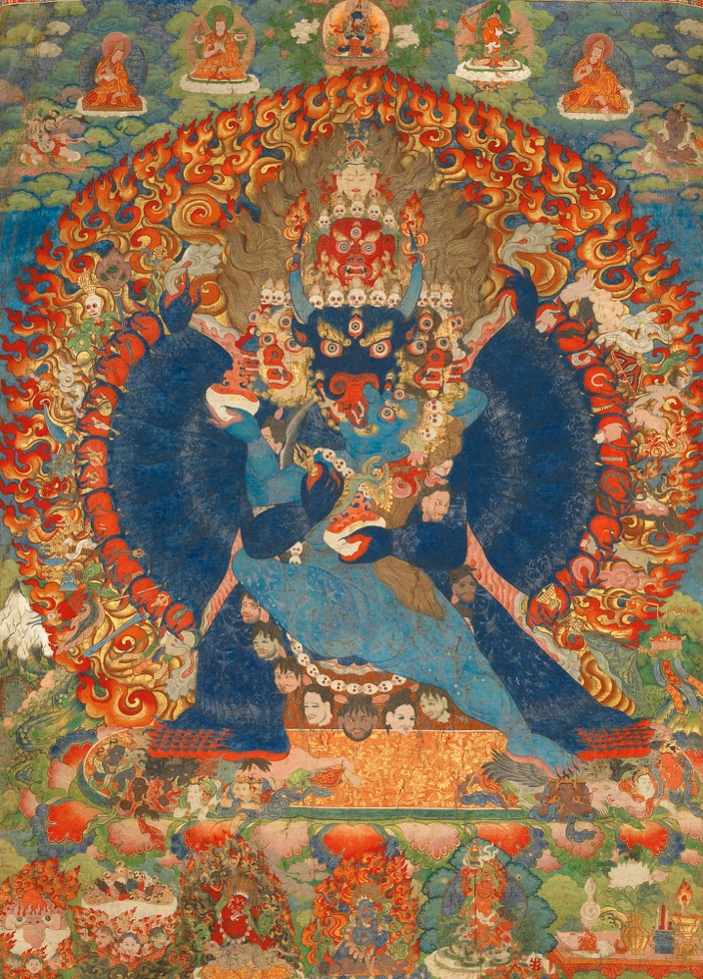
Figure 2. The Tantric Deity Vajrabhairava, circa 1740
This powerful dark blue deity, characterized by many arms and legs, embodies a visual dynamism that mirrors the "ongoing movement and morphing of phosphenes, all parallel to each other." The Thangka features numerous "eye-like structures," such as the god's three eyes and seventeen additional eyes on surrounding celestial beings, all exhibiting the archetypal, round form of phosphenes. The god is enveloped by repetitive elements in the form of stylized skulls, reminiscent of how phosphenes can spontaneously generate kaleidoscopic copies of an initial image. Surrounding the central deity, a "tantric sea of flames" filled with numerous faces, often mirrored, depicts a turbulent yet structured light environment. This is further elaborated by by fields of bright orange with golden flowers beneath the god, and two tantric deities immersed in seas of flames, while another floats in dark green clouds interspersed with small red flames. The intricate symbolism of Tibetan sacred art, ranging from wrathful deities to jeweled mandalas, flames, banners and coloured clouds can be read not only as religious iconography but also as phenomenological maps of internal visionary experience (Nebesky-Wojkowitz, 1975). Floating ribbons in the sky and clouds add to the dynamic, luminous backdrop. Most notably, the footsoles of Vajrabhairava are depicted as "kaleidoscopic fields of alternating red and blue",
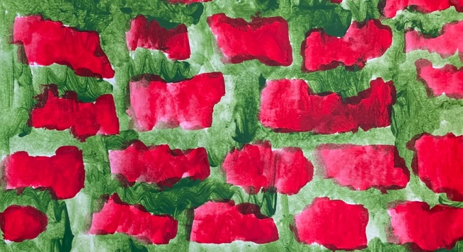  Figure 3a. A phosphene painting by the author, based on alternative red and green bright colours. | 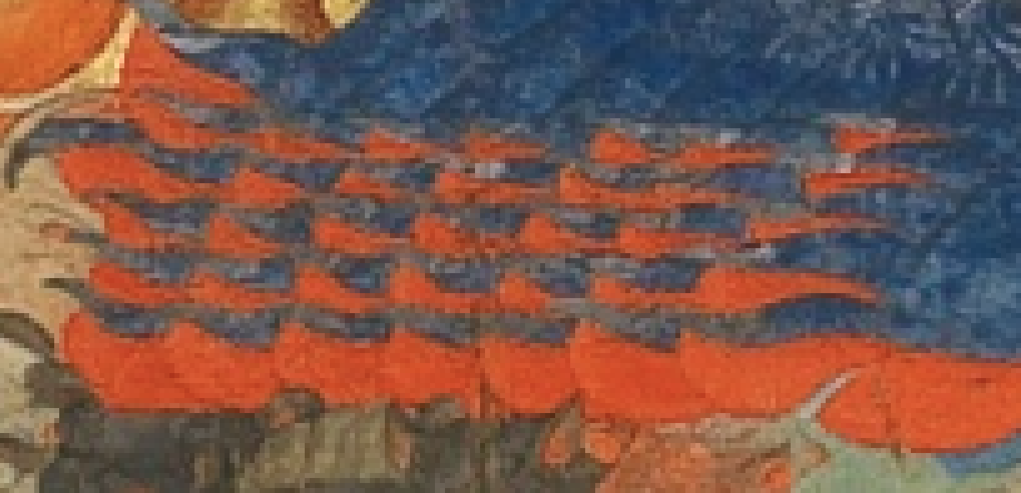  Figure 3b. The foot of the God, also alternative 2 contrasting colours, resembling a phosphene patterns
bearing a strong resemblance to observed phosphene grids, such as a personal painting by one of the authors depicting a green-red phosphene grid. Such intricate and highly organized visual elements strongly suggest that these Thankas function as direct artistic translations of complex, vivid, and dynamic internal phosphene experiences (figures 3a, 3b).
This view suggests that the artists and visionaries of Tibetan Buddhism possessed a profound awareness of both physical and perceptual processes, translating the fleeting nature of both ritual performance and inner light into enduring visual maps. The stylized, often abstract, and luminous qualities of these depictions thus align perfectly with the nature of internally generated light phenomena rather than external observation, serving as a blueprint for guiding practitioners through their own visionary experiences.

6. The Haptic Dimension: Floating Upward and its Integration with Phosphenes
While the visual aspects of the rainbow body and meditative visions are often emphasized, the haptic (tactile and proprioceptive) dimension plays a crucial, yet often overlooked, role. As detailed in the personal account, the sensation of floating upward was not merely an accompanying feeling but was intrinsically linked with the visual ascent of the rainbow banners and the evolving light body. This unification suggests a co-creative process where visual and haptic elements are seamlessly interwoven, each informing and reinforcing the other.
Historical accounts of rainbow body attainments resonate deeply with this haptic dimension. The descriptions of physical bodies dissolving "from the feet upward" and the ancient Bon tradition's "mu cord" allowing kings to ascend directly into the sky illustrate a consistent emphasis on vertical movement and a transformation that involves the body's interaction with a subtle, luminous medium. We propose that the sensation of being lifted or pulled upward during advanced meditative states is a distinct, internally generated haptic experience that can interact dynamically with the visual phosphene patterns. This interaction could lead to the perception of light forms (like the ascending rainbow banners) that appear to actively carry the practitioner upward, creating a powerful and immersive illusion of levitation or ascension. This integrated multi-sensory experience contributes significantly to the profound sense of transformation and liberation associated with the rainbow body.

7. Passive Guru Yoga/Deity Yoga: Becoming the Light Body
The profound integration of visual and haptic experiences, as described, leads to a unique form of spiritual practice that can be termed passive Guru Yoga or Deity Yoga. Unlike conventional Deity Yoga where the practitioner actively visualizes themselves as a specific deity, the experience described here involves a spontaneous, effortless becoming. The luminous form (the evolving light body, the rainbow banners) is not consciously constructed but emerges from the internal perceptual field, and the practitioner finds themselves seamlessly integrated with or becoming that form.
In this passive modality, the internal "phosphene-movie" itself acts as the catalyst for transformation. The light forms spontaneously cohere into a representation of the divine (the luminous body, Vajrasattva in a tent of light), and the haptic sensation of ascension binds the practitioner's sense of self to this emergent luminosity. This leads to a profound dissolution of the subject-object duality, not through intellectual contemplation, but through direct, multisensory experience. The self is not merely observing the light body; it is the light body, carried upwards and merging into the clear light. This spontaneous embodiment represents a direct, non-conceptual recognition of consciousness as its own radiant essence, aligning with the highest non-dual realizations of Dzogchen.

8. Discussion
This paper presents a novel framework for understanding the rainbow body phenomenon and the broader Dzogchen tradition, positing phosphenes as a fundamental neurophysiological basis for profound mystical experiences. By systematically linking detailed textual accounts, a structured taxonomy of inner light visions, and personal phenomenological experience, we argue that the luminous manifestations central to these traditions are not merely symbolic, but represent a systematic, culturally mediated architecture of a collective Ultrasubjective Hyperspace (USH). Clearly the transmissions of great masters to their disciples takes place in this common USH. Thus it is never transmittable by words alone. Words cannot be more than pointers. The essence of the transmission is in the joint experience of the intrinsic luminosity of this space.
Our approach challenges conventional interpretations that often reduce mystical visions to purely metaphorical constructs or attribute them to undifferentiated hallucinations. Instead, we propose that generations of Tibetan masters have cultivated specific meditative techniques (such as sky gazing and dark retreats) that effectively act as "phosphene meditations." These practices systematically induce, stabilize, and refine complex phosphene activity, allowing practitioners to explore the inherent "fractalized compartments" and "sacred geometry of light" that emerge from the very structure of their own consciousness. The "primary clear light," often described as spaceless, timeless, and dimensionless, can be understood as the "structure-function unity" of consciousness itself, revealed through the culmination of this inner exploration (Phase 6 of the taxonomy).
The consistent progression of visions described across diverse traditions, as evidenced by the six-phase taxonomy and corroborated by research on meditation experiences (e.g., Britton & Lindahl), suggests a universal inner architecture of luminous perception. While the underlying neurophysiology of phosphene generation provides the raw material, the specific symbolic and narrative unfolding of these visions (e.g., Vajrasattva in a tent of light, linked vajra sheep, stylized skulls on Thankas) is undeniably shaped by the theological and cultural frameworks of the practitioners. However, our argument emphasizes that these symbols are not arbitrary; they are often born from primary, empirical visual experience, serving as maps for navigating the USH rather than purely abstract inventions.
The integration of the haptic dimension is equally crucial. The inherent feeling of ascent and integration with luminous forms provides a powerful, embodied component to the visual spectacle, lending a sense of tangible reality to the transformation. This multi-sensory synthesis contributes to the profound and transformative nature of experiences like the rainbow body, suggesting that advanced meditative states involve a holistic re-mapping of perceptual reality.
This framework offers significant contributions to several fields:
- Comparative Mysticism: Provides a shared neurophysiological basis for understanding cross-cultural similarities in luminous visionary experiences, allowing for more concrete comparisons.
- Neurophenomenology: Offers a detailed phenomenological taxonomy grounded in specific neural phenomena (phosphenes), fostering a deeper dialogue between first person experience and third person neuroscience.
- Consciousness Studies: Proposes that phosphenes are not merely optical anomalies but can act as gateways to altered states of consciousness, revealing fundamental aspects of consciousness itself, including its non-dual nature in the USH.
- Contemplative Studies: Offers a tangible, experiential framework for practitioners to understand and potentially navigate their own inner luminous experiences, making complex spiritual concepts more accessible.

9. Conclusion
The rainbow body, a pinnacle of spiritual attainment in Tibetan Buddhism, has often been relegated to the realm of the miraculous or purely metaphorical. By interpreting its visual and haptic dimensions through the lens of advanced phosphene generation and the systematic exploration of an Ultrasubjective Hyperspace, this paper offers a novel and tangible framework for understanding this profound phenomenon. We have demonstrated how detailed textual accounts from the Dzogchen tradition, including narratives of mind treasures, the four visions, and specific meditative practices, align remarkably with a six-phase taxonomy of inner luminous experience we described earlier (Keppel Hesselink 2025c; Keppel Hesselink 2025d). This framework illuminates how a lineage of masters has collectively charted an internal reality, where internally generated light forms are not mere artifacts but serve as the very canvas for spiritual insight and transformation. In this shared Ultrasubjective Hyperspace we find the foundations of the entire Bon and Tibetan lineage of teachers related to consciousness as luminosity.
The systematic cultivation of phosphene meditations, coupled with the integral haptic experience of ascent, culminates in a spontaneous, passive integration with the luminous light body, a direct, non-conceptual realization of consciousness as pure radiance. This work suggests that the 'mysticism' of the rainbow body and the profound visions of Dzogchen do not need to be demystified by reduction, but rather re-contextualized as a sophisticated, empirically grounded journey into the very structure-function unity of our own awareness. Further research, combining advanced neuroimaging with detailed first person accounts, could further validate this hypothesis and deepen our understanding of the extraordinary potentials of human consciousness. Furthermore, the descriptions of the lights seen during the dying process, as documented in the Tibetan Book of the Death, can also be understood in the light of morphing phosphenes.

References:
Beer, R. (2003). The handbook of Tibetan Buddhist symbols. Shambhala.
Bressloff, P. C., Cowan, J. D., Golubitsky, M., Thomas, P. J., & Wiener, E. (2002). What geometric visual hallucinations tell us about the cortex. Neural Computation, 14(9), 1987–2001. https://doi.org/10.1162/089976602320264429
Chöwang, G. (1979). Ghuru Chos dbang gis sku’i rnam thar skabs brgyad ma, Dharma Shwara’i rnam thar [The autobiography of Guru Chöwang] (Vol. 1, pp. 1–53). Ugyen Tempai Gyaltsen.
Dowman, K. (2013). Spaciousness: The radical Dzogchen of the Vajra-Heart. Vajra Publications.
Ellis, C., Adams, T. E., & Bochner, A. P. (2011). Autoethnography: An overview. Forum: Qualitative Social Research, 12(1).
Evans-Wentz, W. Y. (Ed.). (1960). The Tibetan book of the dead: Or The after-death experiences on the Bardo Plane, according to Lama Kazi Dawa-Samdup's English rendering (E. P. Kunsang, Trans.). Oxford University Press.
Geisshuesler, F. A. (2024). Tibetan sky-gazing meditation and the pre-history of great perfection Buddhism: The skullward leap technique and the quest for vitality. Bloomsbury Academic.
Gyatso, J. (1998). Apparitions of the self: The secret autobiographies of a Tibetan visionary. Princeton University Press.
Johnson, D., & Hollands, H. (2012). Acute-onset floaters and flashes. CMAJ: Canadian Medical Association Journal, 184(4), 431–431. https://doi.org/10.1503/cmaj.110755
Keppel Hesselink, J. M. (2025a). From flickers to formless: Mapping phosphene trajectories in Tibetan Dzogchen, Christian mysticism, and contemporary meditation. PsyArXiv Preprints. https://osf.io/preprints/psyarxiv/hfvpt_v1
Keppel Hesselink, J. M. (2025b). The ultrasubjective hyperspace: A unified model of consciousness and reality. PsyArXiv Preprints. https://osf.io/preprints/psyarxiv/bh7ru_v1
Keppel Hesselink, J. M. (2025c). From point to eternity: A hierarchical taxonomy and phenomenology of meditation-induced phosphenes and luminous light experiences. PsyArXiv Preprints. https://osf.io/preprints/psyarxiv/cv7u2_v1
Keppel Hesselink, J. M. (2025d). Inner light, inner seeing: A phenomenological inquiry into phosphene meditation and the structure of mystical perception. PsyArXiv Preprints. https://osf.io/preprints/psyarxiv/s56h9_v1
Lindahl, J. R., Kaplan, C. T., Winget, E. M., & Britton, W. B. (2014). A phenomenology of meditation-induced light experiences: Traditional Buddhist and neurobiological perspectives. Frontiers in Psychology, 4, Article 967. https://doi.org/10.3389/fpsyg.2013.00967
Nebesky-Wojkowitz, R. (1975). Oracles and demons of Tibet: The cult and iconography of the Tibetan protective deities. Mouton.
Purves, D., & Lotto, R. B. (2003). Why we see what we do: An empirical theory of vision. Sinauer Associates.
Reynolds, J. M. (2005). The oral tradition from Zhang-Zhung: An introduction to the Bonpo Dzogchen teachings of the oral transmission of Zhang-Zhung. Vajra Publications.
Thondup, T. (1996). The practice of Dzogchen: Longchen Rabjam’s writings on the Great Perfection. Snow Lion Publications.
Tiso, F. V. (2016). Rainbow body and resurrection: Spiritual attainment, the dissolution of the material body, and the case of Khenpo A Chö. North Atlantic Books.
Thompson, E. (2015). Waking, dreaming, being: Self and consciousness in neuroscience, meditation, and philosophy. Columbia University Press.
Tsogyal, Y. (2004). The lotus-born: The life story of Padmasambhava (E. P. Kunsang, Trans.). Rangjung Yeshe Publications.
Varela, F. J. (1996). Neurophenomenology: A methodological remedy for the hard problem. Journal of Consciousness Studies, 3(4), 330–349.
Yeshe, L. (2001). Introduction to Tantra: The transformation of desire. Wisdom Publications.

